Mythos

Warning

Mythos is an anthology of horror. A series of eight sperate stories each about 15 – 20 minutes long.
There isn’t just one setting for this show, each episode has its own setting and time. The horror can happen at any time just like in real life.
This is horror in it’s purest form, the horror of death and consequences where nothing can save you. There is not going to be something the main character can overcome by trying hard or by believing in friends or being clever. Real life is never that easy.

Mythos is Realistic, depressing and horrifying. This whole series is inspired by fantastic horror such as Resident Evil, Silent Hill, The Ring, Scream and many more. Inspired but also improved through more realism in characters and story telling.

Myth and Legend

Myths and Legends are a massive part of our society. Names like Hercules, Mulan, Icarus, and Thor to name a few are so recognisable that they are more well known than a lot of our current public figures.
The really amazing part is how wide spread these myths and legends have become in the modern world. It is slowly becoming a world mythos rather than just a specific country.

So if these Legends are now all over they should be able to pop up anywhere because it is not just the good popular myths, but the boogeymen, the devils and demons. They find themselves suddenly with a whole world to prey upon.
What would happen

Tone and Structure

True terror is the basis of all these episodes but they way they go about it is different for each episode. This is firstly due to a belief that stagnation is a real issue in horror. Rarely does the sequel of a horror movie have the same lasting impact and I believe this has to do with once you have seen it is it really that shocking again. Prime example is Saw; the first movie is a turning point in the genre. An iconic film that pushed our constitutions to the limits with the amount of gore and blood on screen. That and the patchwork story telling that is like piecing together a puzzle.
However, each Saw sequel is a lesser of the one that came before and that is because an audience becomes jaded to things that they are repeatedly exposed to.

Mythos on the other hand benefits greatly from being an anthology, each episode can be a different narrative method, a different shooting style, editing style it keeps audiences guessing and the horror fresh.

The Old Legends
Kuchisake – Onna
Origin – Japan
Description – A young girl that often covers her face for some reason. She looks beautiful but she hides most of her face so all you see is her eyes. I have heard that she has a terrible disfiguration a gash that goes from the corners of her mouth to all through her cheeks to her ears. What a waste of beauty.
History – I heard that there is more than one sort of this spirit. One story says she had an abusive husband that killed her one night by mutilating her face. Another account says she was the adulterer and her husband punished her by sliting her face open. There was even a story that other women were jealous of her beauty so they mutilated her face and let her live.
It does not matter because in any or all cases the spirit of this woman comes back to take revenge not only on those who harmed her but on the rest of this world. This vengeful spirit will never stop, she will never rest.

Advice: Show respect to her if you see her but do not talk to her. Pretend you are busy and pray it is not you she has a grievance with otherwise there is no escape.

Episode structure: This episode is based heavily from Ring, The Grudge and Resident Evil 2. This is all about suspense, simple lighting, fixed camera angles and simple sound design. The Horror comes from the merciless killing and the sense that no one is safe.

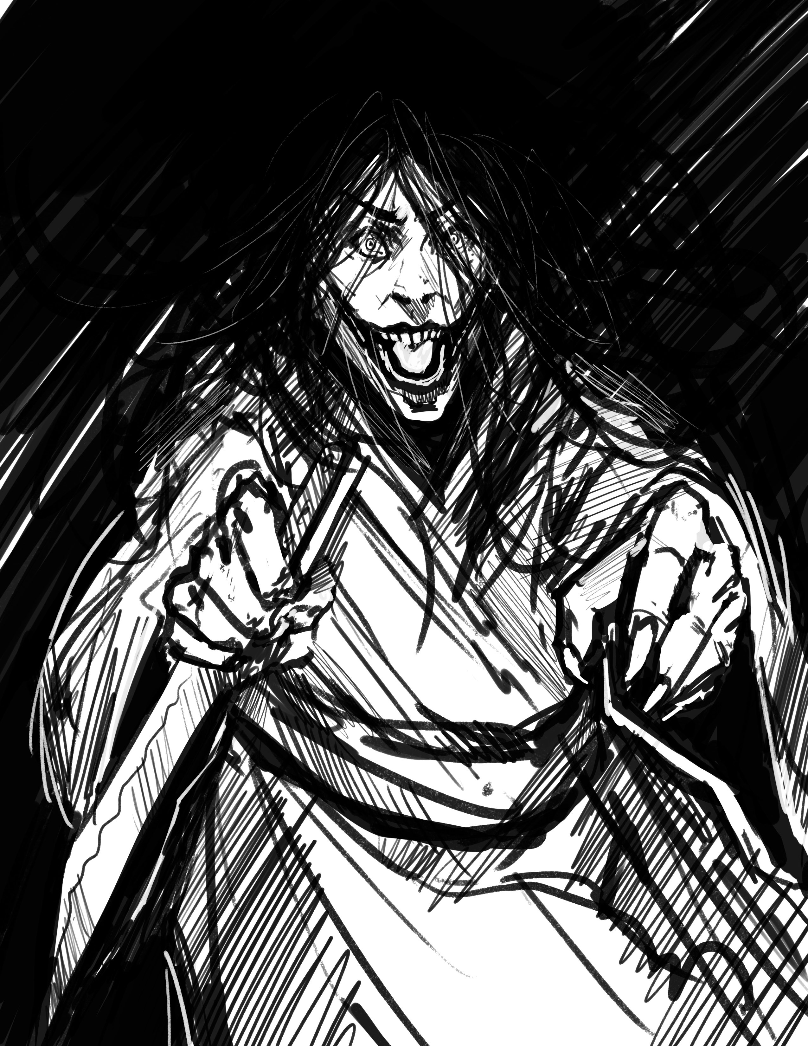

The Morrigan
Origin- Celtic
Description – A shapeshifter that favours the form of young women with black hair. She also assumes the guise of crows. Still as she can change forms there is no way to know who she is or see her coming

History – The Morrigan is a goddess who is associated with the entire life cycle including birth and death. She is also associated with revenge, witches, magic and the night.
Throughout time however The Morrigan has proven vindictive to those who would slight her or show her disrespect, not hesitating to kill anyone that she wished.

Advice – Avoid at all costs if you do encounter her be respectful but all you can really hope for is that she gets bored of you and leaves to find someone else

Episode Structure – Inspired from The Mist, and Silent Hill this short is meant to be horror in the form of the unknown. When the character is lost and alone the entire time their actions always manipulated to outcomes the suit only The Morrigan.

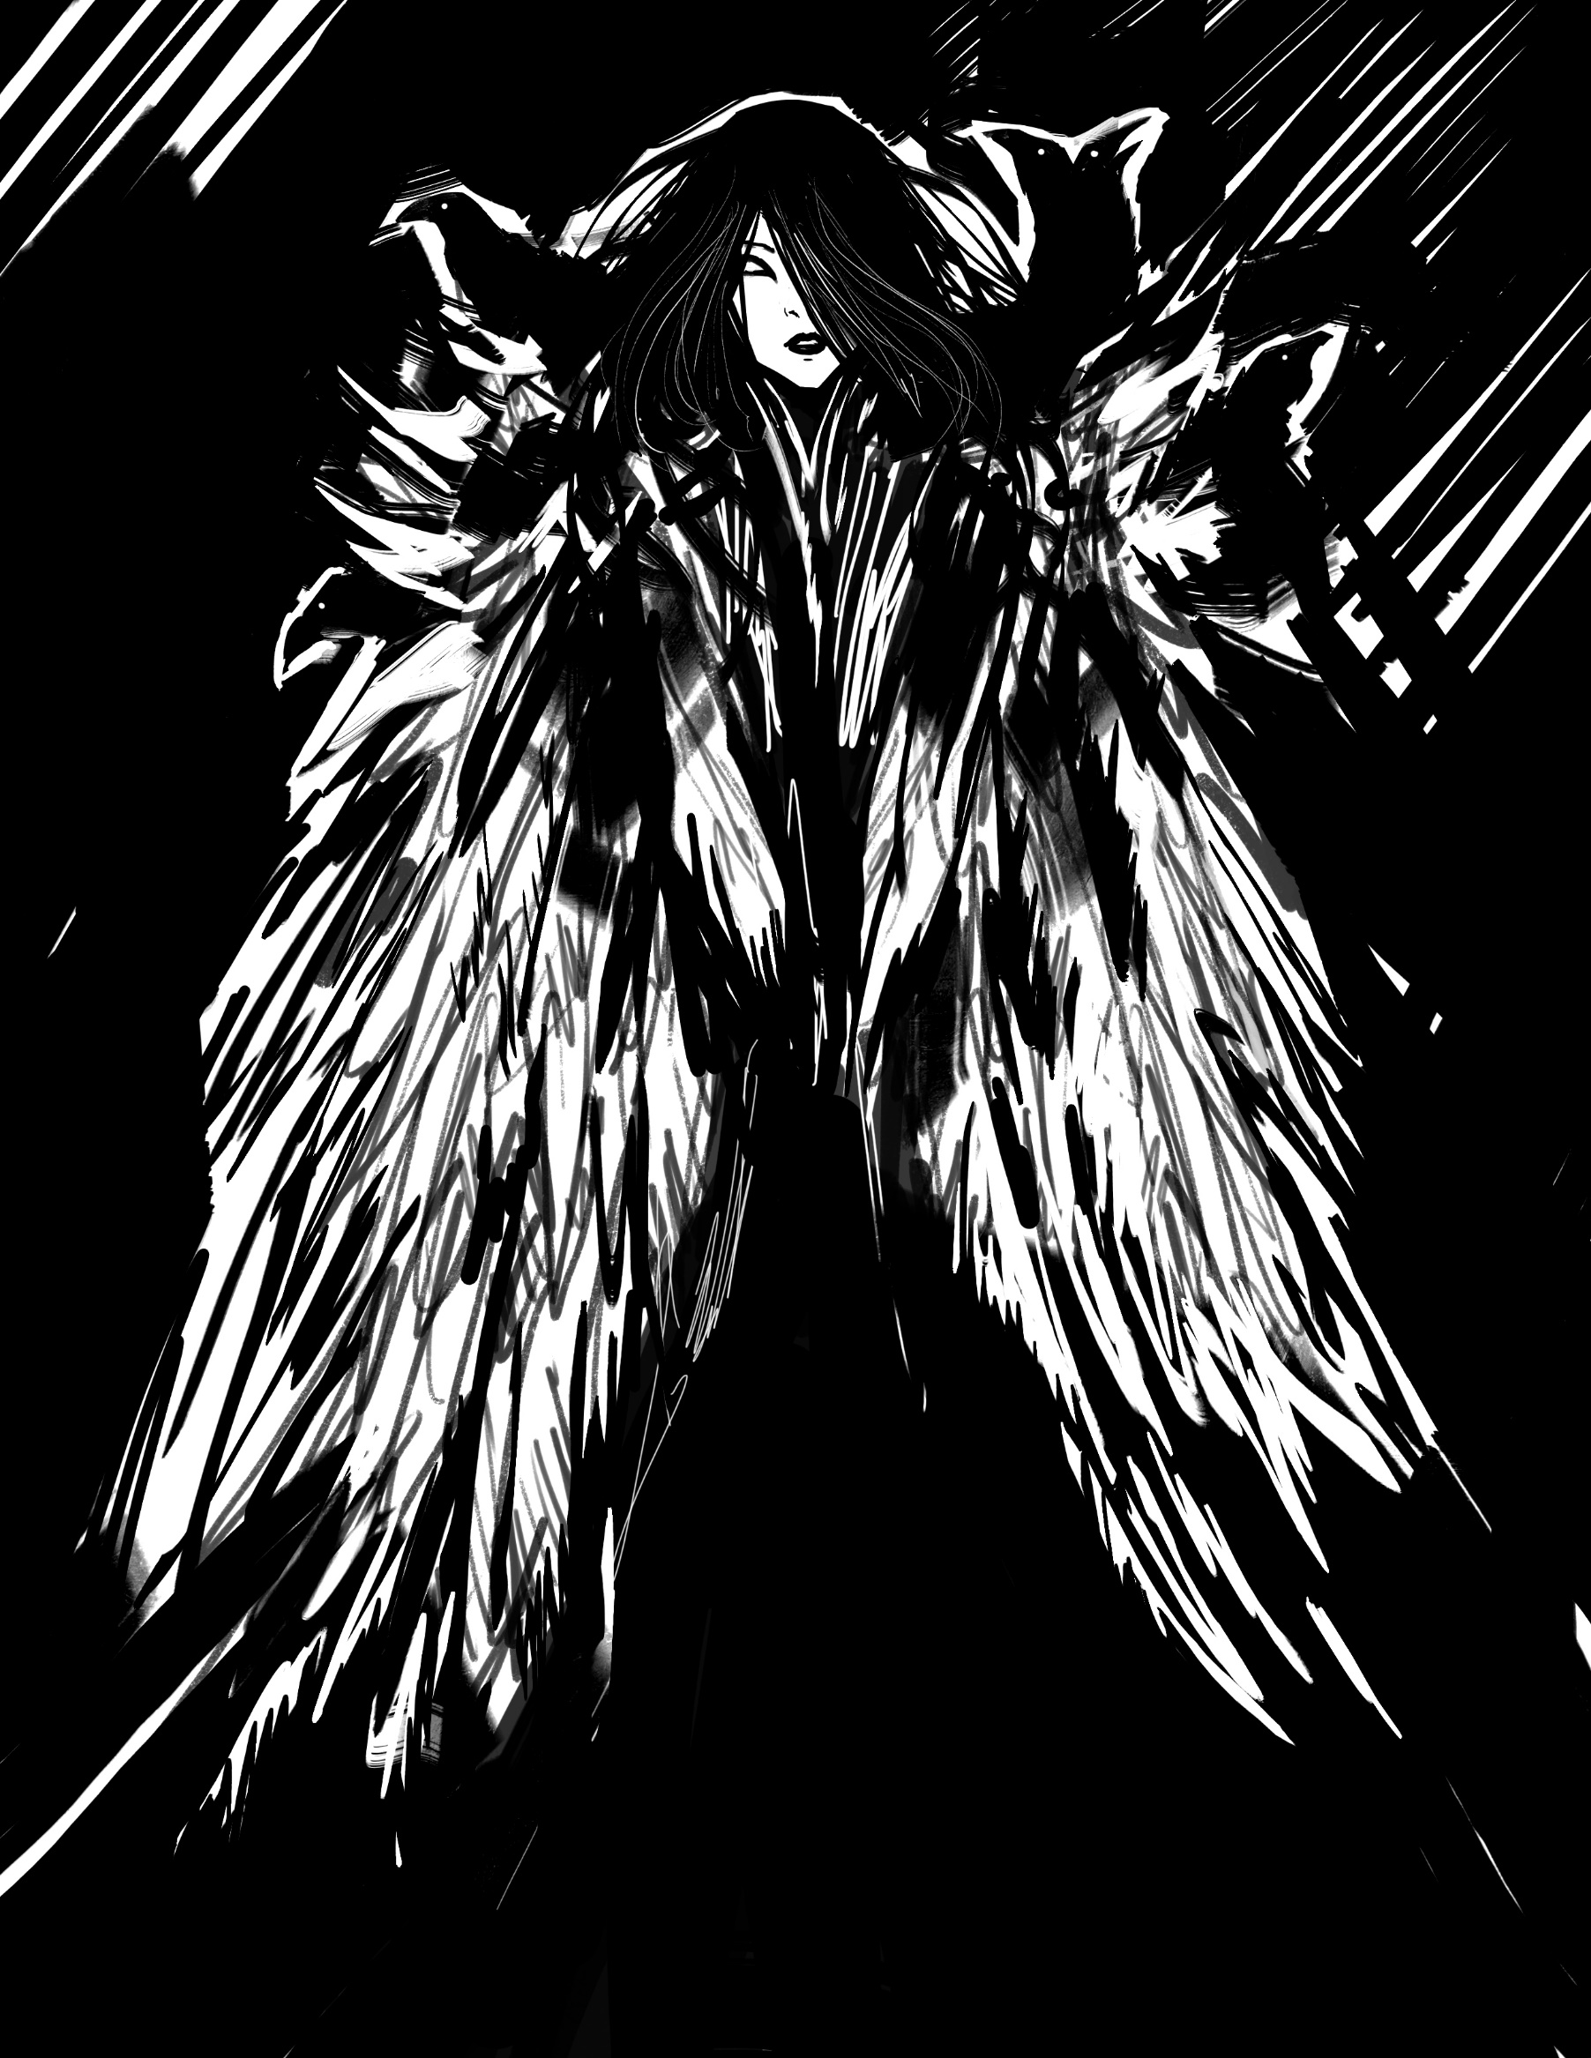

Shui Gui
The Drowned ones
Origin – China
Description – you will never see these ghosts until it is too late. They are horrifying to look upon because of this we can only imagine how these spirits look. That is until they look like us…

History – Shui Gui and the spirits of the drowned. They lurk near the place that they died waiting for the opportunity to grab anyone that strays too near and drown them as well. When they do this the Shui Gui swaps places with the victim’s spirit allowing the drowned one to live once more. Whilst leaving a new Shui Gui in its place

Advice – Stay away from the water……

Episode Structure – This is a Short that is inspired by The Thing, an amazing movie that did so many things right but the highest on that list is the feeling it gave off. The feeling of not being able to trust anyone because any of them could be The Thing.
To improve on this idea though is the sheer number of Shui Gui so not only is it the terror of being unable to trust but also the overwhelming number of people that could be turned at any point.

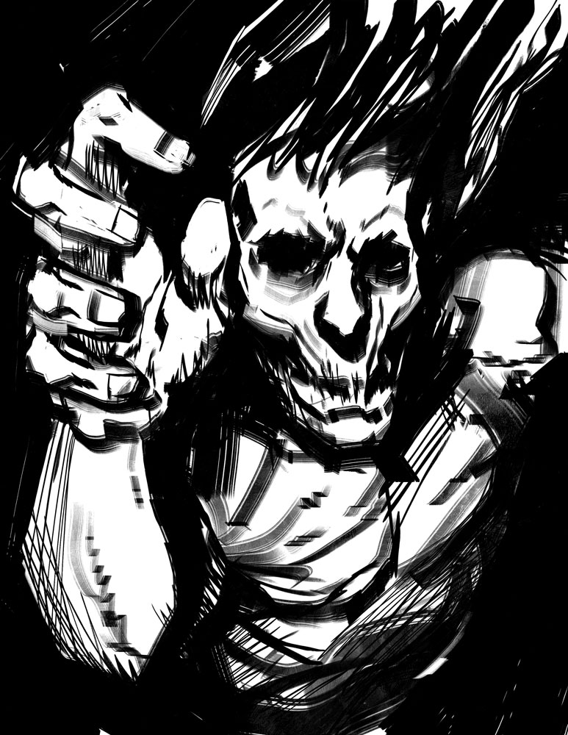

Vampires

Origin – Eastern Europe/ sort of worldwide

Description – Creatures of the undead, they feast on humans to survive by draining their blood. This is widely known by this point the real descriptor here is that they can look like anyone. Anyone at all they have no defining characteristics.

History – Vampires or other forms of vampirism have been known throughout the world in one form of another for hundreds if not thousands of years. It is arguably one of the most famous monsters in the world. They have not always been accurately represented however and these vampires have existed for a long time so how much of what we know is fact or fiction.

Advice – I have none to give with so much of what we know not reliable I won’t give bad advice just keep an eye out.

Episode Structure – This may be the most ambitious episode of them all. Inspired from The Mortuary Assistant and Resident Evil 7 I want this whole short to be a first person perspective perhaps even a 180 or 360 video. The latter two options are significantly harder to achieve but could be amazing. The first person aspect however I believe to be pivotal to the terror of a vampire that can appear anywhere.

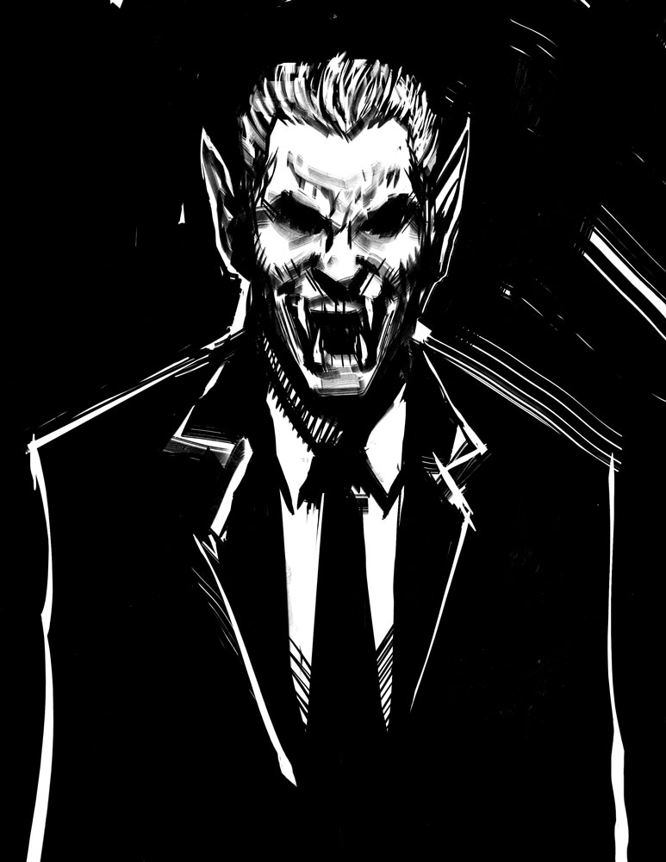
Jinn

Origin - Middle East
Description – Beings of the elements they do not know right or wrong. Without form unless they wish it so they are beyond our primitive thinking
History – These beings pop up from time to time sometimes they are the catalyst for great positivity but just like humanity there are good jinn and then there are bad. This race is older than our own by far and view the universe in a different way to us. Their life spans far exceed our own so much so that the life of man is nothing relative to a Jinn.

Episode Structure – I want this to be another supernatural horror like the Morrigan where it isn’t so much the monster as the protagonist we are focusing on. Taking inspiration from the Shining, Bioshock and F.E.A.R it is the mistakes of the protagannist that alter his story which differs to the Morrigan which is to do with the lack of free will and sense of inevitability

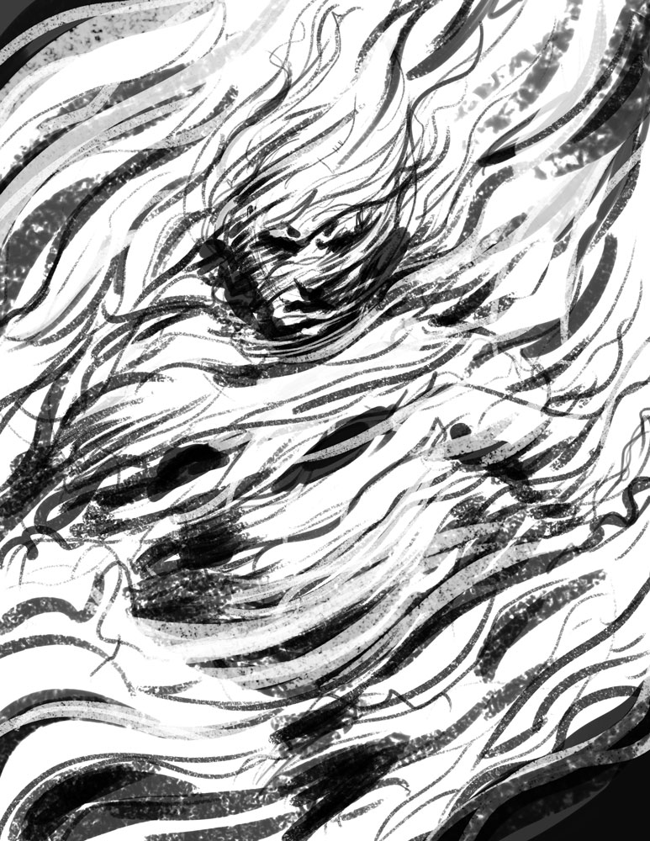
The Ripper
Origin - United Kingdom
Description – N/A
History – Not just limited to one throught history man often has its own monsters, able to end life mercilessly. Sometimes it is calculated, motivated and ruthless. There are times though where someone starts killing on a whim not driven by anything other than impulse.
Advice – trust no one

Episode Structure – This is inspired on the resent resurgence of the slasher and home invasion genre in horror in America. The latest Halloween, Hush, You’re Next and Knock Knock to name a few. These films improved so much on the old slasher formula, however with more realistic characters and more realistic world rules I believe they can truly resemble the horror of this happening to anyone.

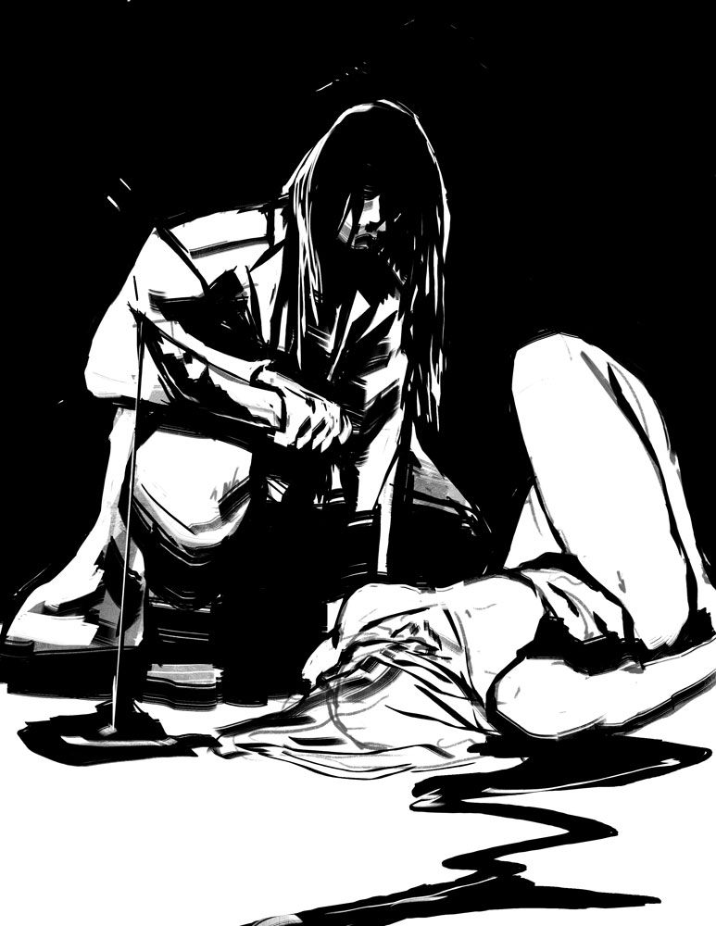

Bakasura
Origin – Hinduism
Description – A Demon that consumes whatever he desires. Covered in bones and only vaguely human this being is incredibly strong and there is no fighting back.
History – A demon from ancient times that used to demand tribute from a village. When that tribute is brought to him he often ate the people baring the tribute as well. He was finally defeated by Bhima a man that not even the gods could subdue.
Advice – Give into whatever he demands of you for that Is the only way the average human stands a chance at surviving.

Episode Structure – This episode needs to be treated carefully so that it does not feel to similar to the vampire and Jinn episodes. However I believe it can work by firstly not seeing much of the monster at all. Instead focusing on the horror of a monster forcing a family to make the hardest decision of all. Who will survive

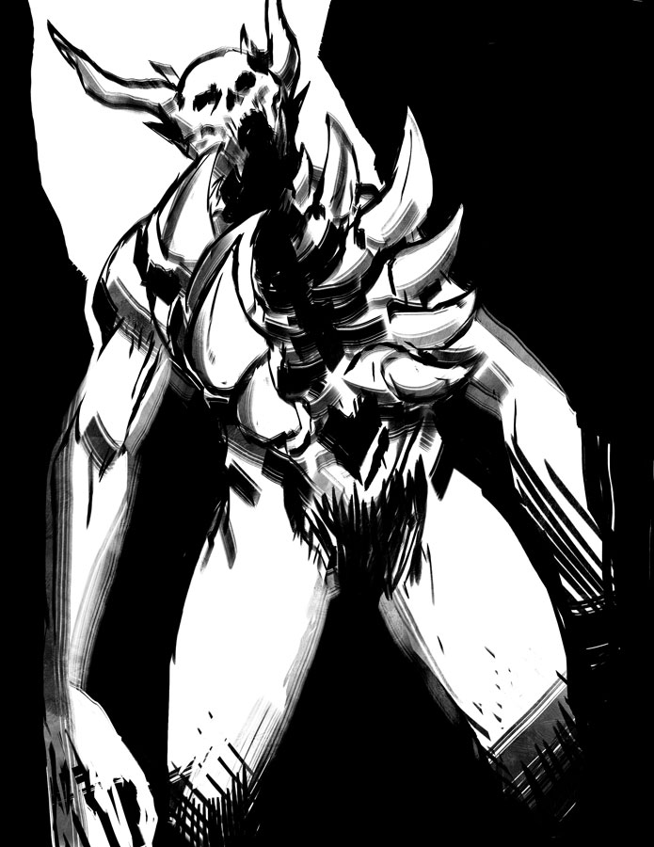
The Few
No Origin
No Description
There have always been those who stand on top. Those in power. Those who control our lives sometimes in obvious ways others less so.
You may be able to identify them but it will do you no good for they hold all the cards and all the power.
This has been the same across the world for thousands of years. The Few will always have power over the many.

Episode structure: The other in the most ambitious of projects. I wanted this to be an action horror. Influenced by films like Ghostwire Tokyo, Underworld, Blade, Predator and Tag.
The horror from this episode would come from the brutality of the shooting style without going overboard like in SAW. Also I am aiming for it to be the longest of the episodes at 20 – 25 minutes that ends the season with people wanting more.

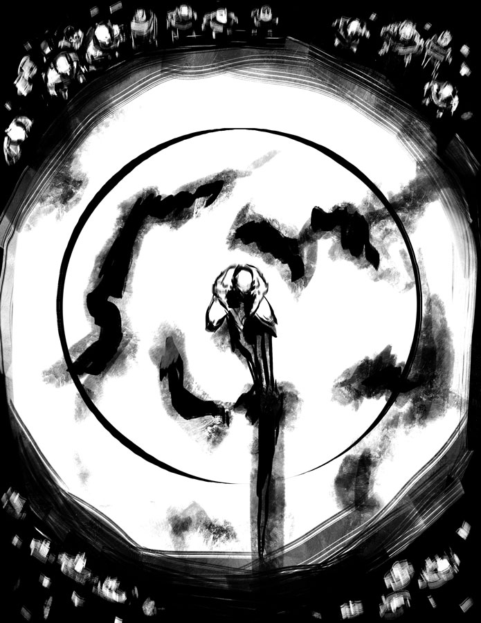
Potential of the series

Every episode of this series is trying something new. They have different narrative methods and shooting styles all used to impact that specific creature and film. As a series I believe it could evolve and continue after this. Perhaps the second series is more interlinked with a running theme between each episode focusing more on character growth across the episodes.
There is so many different cultures in the world that the potential for more episodes is limitless across other time periods and perhaps even slightly different genres.

